Introduction

There is extensive epidemiological evidence that the amount of fruit and vegetable intake has an impact on cancer prevention particularly with cancers of the digestive system. However, the differences in behavior between those that have cancer and those that just have a family history of cancer is not known. In this paper, we will investigate the differences in servings per day of fruit and vegetables and minutes of physical activity between these two groups.

These data are from the Health Information National Trends Survey (HINTS) data from the National Cancer Institute. I chose HINTS 4 Cycle 2 as a starting point for these analyses because it had questions on BMI, cancer history, questions pertaining to screening history and information on diet and exercise. I initially was interested in exploring relationships between healthy lifestyle behaviors and incidence of prostate cancer in people with and without a family history. However, there are few in the dataset that have or have had prostate cancer, therefore I am expanding the question to differences between family history of any cancer to those that have or have had any cancer. In the future, these may be better limited to those with digestive tract cancers since this is where the most evidence lies about fruit and vegetable intake.

Methods

Data

The HINTS data is a nationwide and population-based cross-sectional computer-assisted telephone survey that collects various cancer-related information, focusing on health technology and communication. It is not conducted every year and not all questions are continued each year. HINTS 4 Cycle 2 was conducted in 2012 and contained questions about cancer history, body mass index, fruit and vegetable intake and physical activity habits in adults aged 18 or older.

Study population

I included all participants that answered yes to either having a family history of cancer or having had cancer currently or in the past. I realize there could be a cohort of cancer patients with a family history, but this will be left for future analyses. XX were excluded from the sample because of missing. The American Cancer Society recommends meeting the Physical Activity Guidelines of 150 minutes of moderate intensity or 75 minutes of vigorous intensity aerobic activity per week (no mention of strength training) and consuming at least 2.5 cups of fruits and vegetables per day, which is less than the USDA recommendations. I further restricted the data to exclude those missing physical activity and fruit and vegetable serving information (fruit missing n= 135, vegetable missing n= 134). The variable corresponding to number of days per week of moderate aerobic exercise was used as a proxy for physical activity. Due to the logic arrangement of the exercise variables, limiting to days reduced the number of extraneous values for this variable. Number of days of strength training was also reported in the characteristic tables but not the model. It is known that education level can mediate fruit and vegetable intake and physical activity level, so this was used as a covariate. Age and smoking status were also used as covariates. Smoking behavior questions are limited in the HINTS surveys, but there is a recoded variable available called smokeStat. This combines two variables were used to determine current smoking status. The question "Have you smoked at least 100 cigarettes in your entire life?" was used to define never smokers and "How often do you now smoke cigarettes?" was used to define this smoke Stat variable. Education is categorized by less than high school, high school graduate, some college and college graduate or higher (missing n= 89). The variables Fruit and Vegetables were combined to compare with ACS recommendations and are reported in cups. This loaded dataset was simplified in SPSS before importing to R. Missing data are coded in a variety of ways in this dataset. Most ways are with a negative number of some kind. I recoded them as NA, so they would be ignored when used in physical activity calculations.

Statistical Analysis

All results are displayed as unweighted population estimates and were conducted using R version 3.6.1 (2019). Univariate analysis included tests to determine the differences between demographics and health behavior variables differed between those with a family history of cancer and those that have had or currently have cancer. Then to determine association between cancer status and fruit and vegetable intake and then physical activity I used a multivariate logistic regression model that controlled for statistically significant or clinically meaningful variables. The two models were compared using ROC curves and confusion matrices. An alpha of 0.05 was used to determine significance for univariate analyses, and 95% confidence intervals for odds ratios and significance of covariates.

Results and Discussion

There are 3630 total survey participants in these data. Tables 1 and 2 report the overall demographics and average fruit and vegetable servings and the differences between those that have or have had a cancer and between those with and without a family history of cancer. To highlight, there were more differences between those that had or currently had a cancer versus not than between family history status with the exception of gender. The overall split in gender was a bit skewed with 40% male. Fruit and vegetable servings (in cups) did not differ between groups and averaged around 2 cups each. The average number of days of aerobic exercise was between 2 and 3 days and the number of strength training days averaged 1 per week and neither of these differed between comparisons. Figure 1 shows the differences in prevalence of current cancer status (first panel) and family history of cancer status (second panel) from the survey respondents. Figure 2 shows a correlation matrix between all of the chosen variables. Because of the order I completed things for this project, I had chosen the variables and the question before I had a chance to really investigate these correlations and therefore there were no significant differences between these groups. Table 3 shows the odds ratios and 95% confidence intervals for each model and corresponding covariates. As you can see, the only significant variable was smoking status, which makes sense when comparing those with cancer and those without. Figure 3 and table 4 show some analysis of the fit of these models. Figure 3 are the probability plots for each outcome and each comparison group. The significance line was 0.2 for the family history comparison and 0.5 for the current cancer comparison. Table 4 displays the confusion matrices. There were a considerable number of false positives in each comparison. The area under the curve for each model are as follows. For the fruit and vegetable model between family history of cancer – 0.55, days of aerobic exercise model between family history of cancer – 0.52, fruit and vegetable model between current cancer status – 0.75, days of aerobic exercise model between current cancer status – 0.72. Due to these results, the models were not compared any further. Neither model showed a significant association between fruit and vegetable intake and cancer status or days of aerobic exercise and cancer status. Although, the current cancer status models did have better area under the curve values. This suggests there may be more of a relationship between current cancer status and healthy lifestyle behaviors. This was the opposite of my working hypothesis, which was that healthy lifestyle behaviors like nutrition and exercise were more helpful in the prevention of cancer. These results can be interpreted as those that have had cancer may be more apt to improve their lifestyle than those that have a family history of cancer. This also may mean that the public health message and education in not reaching those at risk for cancer until they already have the disease. This research question was determined prior to acquisition of the data and while there was a context for the question, it did not show significance in these data.

Table 1. Characteristics Overall and by Current Cancer Status

|  |  |  |  |  |
| --- | --- | --- | --- | --- |
| Characteristic | Overall (n=3630) | Current Cancer (n=464) | No Current Cancer (n=3135) | p-value |
| Age [mean(SD)] | 51.8 (19.7) | 64.7 (15.7) | 50.4 (18.9) | <0.001 |
| Sex |  |  |  | 0.090 |
| (%male) | 1390 (38%) | 3(10%) | 200(43%) |  |
| (%female) | 2172 (60%) | 18(58%) | 258(56%) |  |
| Missing | 68 (2%) | 10(32%) | 6(1%) |  |
| Race/Ethnicity |  |  |  | <0.001 |
| Hispanic | 511(14%) |  |  |  |
| Non-Hispanic White | 2043(56%) | 4 (12.9) | 320 (69.0) |  |
| Non-Hispanic Black or African American | 496(14%) | 1 (3.2) | 39 (8.4) |  |
| Non-Hispanic American Indian or Alaska Native | 14(<1%) | 0 (0.0) | 2 (0.4) |  |
| Non-Hispanic Asian | 98(3%) | 1 (3.2) | 6 (1.3) |  |
| Non-Hispanic Native Hawaiian or other Pacific Islander | 6(<1%) | 0 (0.0) | 0 (0.0) |  |
| Non-Hispanic Multiple Races Mentioned | 90(3%) | 0 (0.0) | 10 (2.2) |  |
| Missing | 372(10%) | 24 (77%) | 45(10%) |  |
| Marital Status (%) |  |  |  | <0.001 |
| Married or Living as Married | 1857(51%) | 4 (13%) | 246(53%) |  |
| Divorced or Separated | 666(18%) | 2(6%) | 90(19%) |  |
| Widowed | 377(10%) | 2(7%) | 79(17%) |  |
| Single, never married | 628(17%) | 1(3%) | 40(9%) |  |
| Missing | 88(2%) | 22(71%) | 9(2%) |  |
| Education (%) |  |  |  | <0.001 |
| Less than high school | 329(9%) | 2(6%) | 42(9%) |  |
| 12 years or high school graduate | 775(21%) | 2(7%) | 106(23%) |  |
| Vocational or technical school | 267(7%) | 0(0%) | 32(7%) |  |
| Some College | 790(22%) | 3(10%) | 119(26%) |  |
| College graduate | 845(23%) | 0(0%) | 67(14%) |  |
| Postgraduate | 535(15%) | 0(0%) | 93(20%) |  |
| Missing | 89(3%) | 24(77%) | 5(1%) |  |
| Household Income |  |  |  | 0.027 |
| Less than $20,000 | 740(20%) | 6(19%) | 84(18%) |  |
| $20,000 to < $35,000 | 501(14%) | 1(3%) | 64(14%) |  |
| $35,000 to < $50,000 | 459(13%) | 1(3%) | 59(13%) |  |
| $50,000 to < $75,000 | 524(14%) | 0(0%) | 64(14%) |  |
| $75,000 or More | 926(26%) | 0(0%) | 111(24%) |  |
| Missing | 480(13%) | 23(74%) | 82(18%) |  |
| Smoking Status (%) |  |  |  | <0.001 |
| Current | 586(16%) | 3(10%) | 63(14%) |  |
| Former | 939(26%) | 6(19%) | 165(36%) |  |
| Never | 2052(57%) | 14(45%) | 229(49%) |  |
| Missing | 53(2%) | 8(26%) | 7(2%) |  |
| Fruit (cups) [mean(SD)] | 2.0 (2.4) | 2.0 (2.5) | 2.0 (2.4) | 0.938 |
| Vegetables (cups) [mean(SD)] | 2.3 (2.5) | 2.3 (2.6) | 2.3 (2.4) | 0.939 |
| Days of Moderate Aerobic Exercise (days) [mean(SD)] | 2.6 (2.4) | 2.5 (2.5) | 2.6 (2.4) | 0.675 |
| Days of Strength Training (days) [mean(SD)] | 1 (2.3) | 1 (2.3) | 1 (2.2) | 0.662 |

Table 2. Characteristics by Family History of Cancer status

|  |  |  |  |
| --- | --- | --- | --- |
| Characteristic | Family History of Cancer (n=2412) | No Family History of Cancer (n=870) | P-value |
| Age [mean(SD)] | 53.3 (17.5) | 52.4 (18.6) | 0.167 |
| Sex |  |  | <0.001 |
| (%male) | 888 (37%) | 377 (43%) |  |
| (%female) | 1498 (62%) | 477 (55%) |  |
| Missing | 26 (1%) | 16 (2%) |  |
| Race/Ethnicity |  |  | <0.001 |
| Hispanic | 297 (12%) | 155 (18%) |  |
| Non-Hispanic White | 1487 (62%) | 442 (51%) |  |
| Non-Hispanic Black or African American | 309 (13%) | 126 (15%) |  |
| Non-Hispanic American Indian or Alaska Native | 7 (0.3%) | 4 (0.5%) |  |
| Non-Hispanic Asian | 41 (2%) | 51 (6%) |  |
| Non-Hispanic Native Hawaiian or other Pacific Islander | 4 (0.2%) | 2 (0.2%) |  |
| Non-Hispanic Multiple Races Mentioned | 65 (3%) | 20 (2%) |  |
| Missing | 202 (8%) | 70 (8%) |  |
| Marital Status (%) |  |  | 0.432 |
| Married or Living as Married | 1246 (52%) | 469 (54%) |  |
| Divorced or Separated | 440 (18%) | 157 (18%) |  |
| Widowed | 260 (11%) | 79 (9%) |  |
| Single, never married | 431 (18%) | 148 (17%) |  |
| Missing | 29 (1%) | 17 (2%) |  |
| Education (%) |  |  | 0.674 |
| Less than high school | 200 (9%) | 76 (9%) |  |
| 12 years or high school graduate | 505 (21%) | 187 (22%) |  |
| Vocational or technical school | 166 (7%) | 73 (8%) |  |
| Some College | 547 (23%) | 173 (20%) |  |
| College graduate | 582 (24%) | 216 (25%) |  |
| Postgraduate | 381 (16%) | 136 (16%) |  |
| Missing | 21 (1%) | 9 (1%) |  |
| Household Income |  |  | 0.322 |
| Less than $20,000 | 469 (19%) | 164 (19%) |  |
| $20,000 to < $35,000 | 339 (14%) | 120 (14%) |  |
| $35,000 to < $50,000 | 298 (12%) | 124 (14%) |  |
| $50,000 to < $75,000 | 368 (15%) | 121 (14%) |  |
| $75,000 or More | 631 (26%) | 247 (28%) |  |
| Missing | 307 (13%) | 94 (11%) |  |
| Smoking Status (%) |  |  | <0.001 |
| Current | 413 (17%) | 113 (13%) |  |
| Former | 652 (27%) | 200 (23%) |  |
| Never | 1322 (55%) | 543 (62%) |  |
| Missing | 25 (1%) | 14 (2%) |  |
| Fruit (cups) [mean(SD)] | 2.0 (2.3) | 2.1 (2.4) | 0.380 |
| Vegetables (cups) [mean(SD)] | 2.4 (2.4) | 2.3 (2.5) | 0.465 |
| Days of Moderate Aerobic Exercise (days) [mean(SD)] | 2.5 (2.4) | 2.6 (2.3) | 0.314 |
| Days of Strength Training (days) [mean(SD)] | 1 (2.2) | 1 (2.2) | 0.441 |

Figure 1. Differences in number of survey responses between current cancer status and family history of cancer status

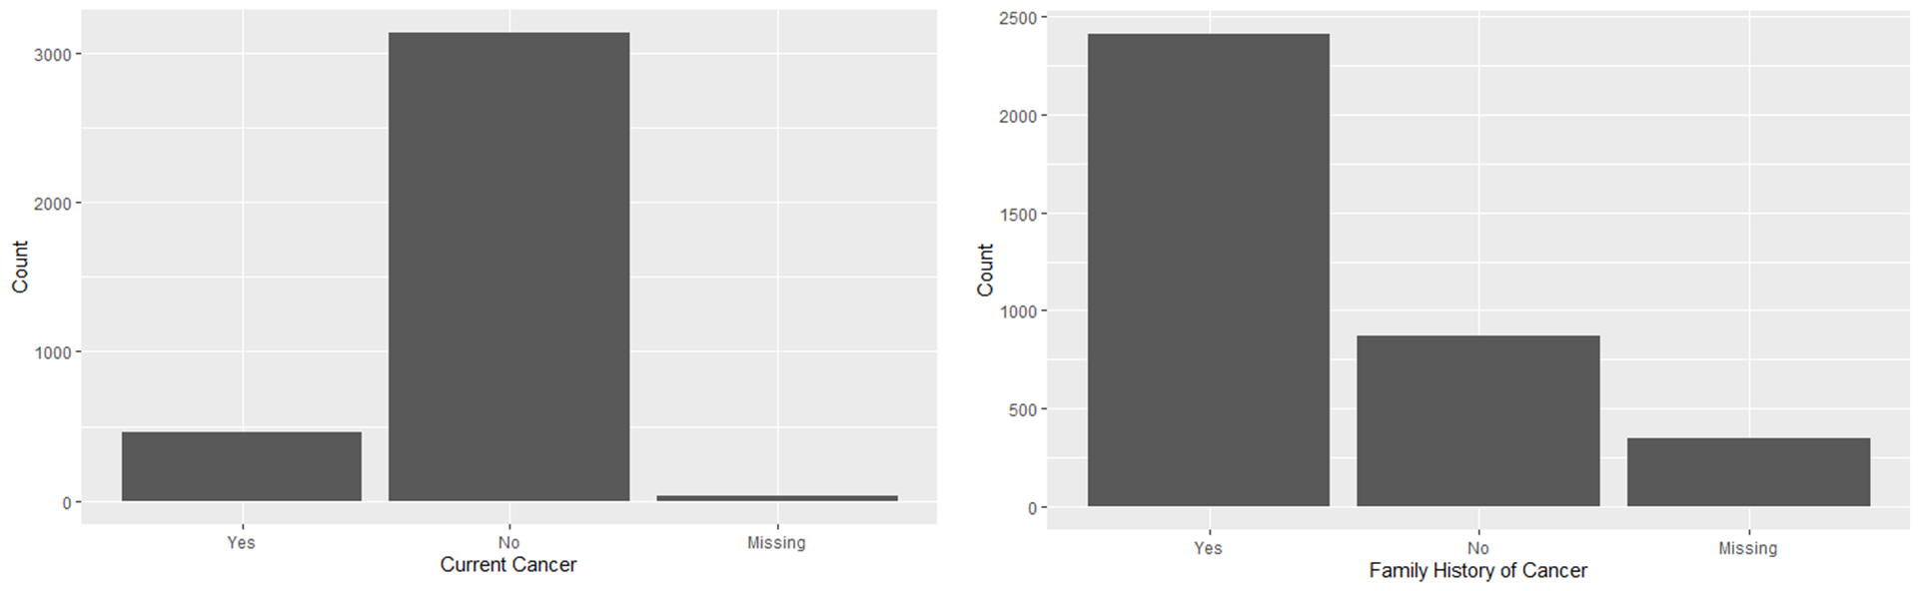

Figure 2 Correlation matrix prior to transformation and removal of outliers

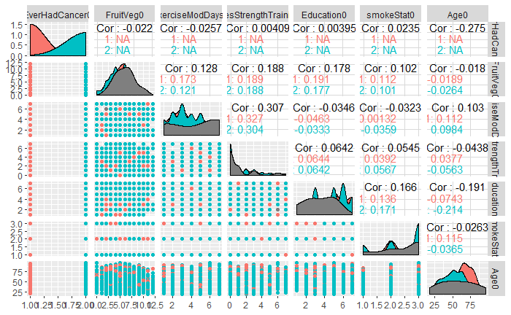

Table 3 Multivariate logistic regression model between those with a family history of cancer versus no family history and those that have had or have cancer versus those that have not

|  |  |  |  |  |
| --- | --- | --- | --- | --- |
|  | **Family History of Cancer** | | **Current Cancer** | |
| **Fruit and Veg Model** | **Odds Ratio** | **95% CI** | **Odds Ratio** | **95% CI** |
| Intercept | 0.21 | 0.12, 0.36 | 251.72 | 118.53, 548.89 |
| Fruit and Vegetable intake | 1.01 | 0.97, 1.05 | 0.97 | 0.93, 1.03 |
| Education | 0.98 | 0.93, 1.04 | 0.91 | 0.85, 0.98 |
| Age | 1.00 | 0.99, 1.00 | 0.94 | 0.93, 0.95 |
| Smoking Status | 1.28 | 1.13, 1.46 | 1.17 | 0.99, 1.37 |
| **Exercise Model** | **Odds Ratio** | **95% CI** | **Odds Ratio** | **95% CI** |
| Intercept | 0.26 | 0.14, 0.50 | 445.83 | 172.51, 1202.54 |
| Aerobic Exercise Days | 0.97 | 0.92, 1.03 | 1.00 | 0.93, 1.08 |
| Education | 0.98 | 0.92, 1.05 | 0.86 | 0.79, 0.94 |
| Age | 1.00 | 0.99, 1.01 | 0.93 | 0.92, 0.94 |
| Smoking Status | 1.28 | 1.1, 1.49 | 1.21 | 0.97, 1.48 |

Figure 3 Prediction Probability Plots

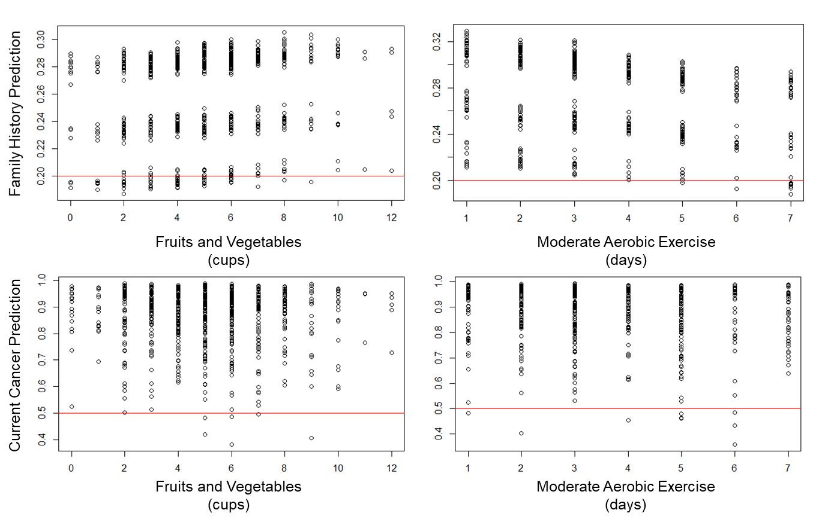

Table 4. Confusion Matrices for each model

|  |  |  |  |  |
| --- | --- | --- | --- | --- |
|  | **Family History of Cancer** | | **Current Cancer** | |
| **Fruit and Veg Model** | **True** | **False** | **True** | **False** |
| Yes | 413 | 46 | 68 | 2 |
| No | 154 | 12 | 603 | 4 |
| **Exercise Model** | **True** | **False** | **True** | **False** |
| Yes | 314 | 4 | 46 | 2 |
| No | 119 | 4 | 421 | 8 |